Student’s name Teacher’s name

________________________________________ _____________________________

2016
10 5.2 Course Semester 2 Examination

General Instructions  - Reading time – 2 minutes  - Working time –60 minutes  - Write using blue or black pen  Black pen is preferred  - Scientific calculators may be used | Total Marks – 60  - Questions arranged in topics. Attempt questions from all topics.

Section | 1 | 2 | 3 | Total
 | $$\frac{}{20}$$ | $$\frac{}{20}$$ | $$\frac{}{20}$$

Student Comment:

Teacher Comment:
Linear and Non Linear Relationships
20 marks
Attempt all Questions
Questions 1 to 4 Multiple choice
Allow about 15 - 20 minutes for this section

Circle the correct answer for Questions 1 to 5

Questions 1-2 refer to the diagram below

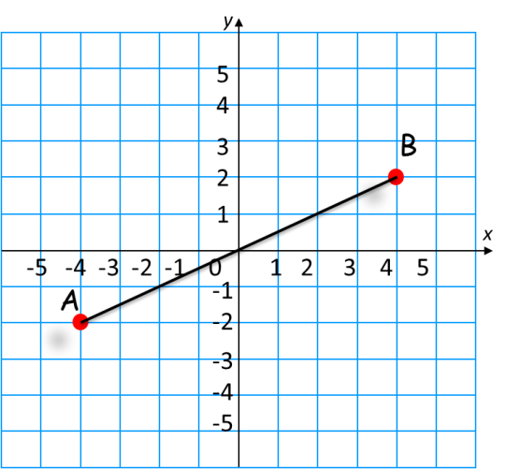

1. | The gradient of interval AB is:
 | (A) 2 |  | (B) -2 |  | (C) 1 |  | (D) -1
2. | The mid-point of interval AB is:
 | (A) (0 , 0) |  | (B) (-1 , 0.5) |  | (C) (1 , -0.5) |  | (D) (-0.5 , 1)
3. | Line LM has a gradient of -4. Line CD is perpendicular to line AB. The gradient of line CD is:
 | (A) 1/4 |  |  | (B) -1/4 |  | (C) 8 |  | (D) -8
4. | Which one of the following lines does the point (3, 7) lie on?
 | (A) y = 3x - 4 |  |  |  | (B) y = 2x + 1
 | (C) y = -2x + 7 |  |  |  | (D) y = 2 x - 7
Questions 6-9 Short Answer. Show all working. Marks are as shown

6. |  | Parts a, b, and c refer to the graph shown below.  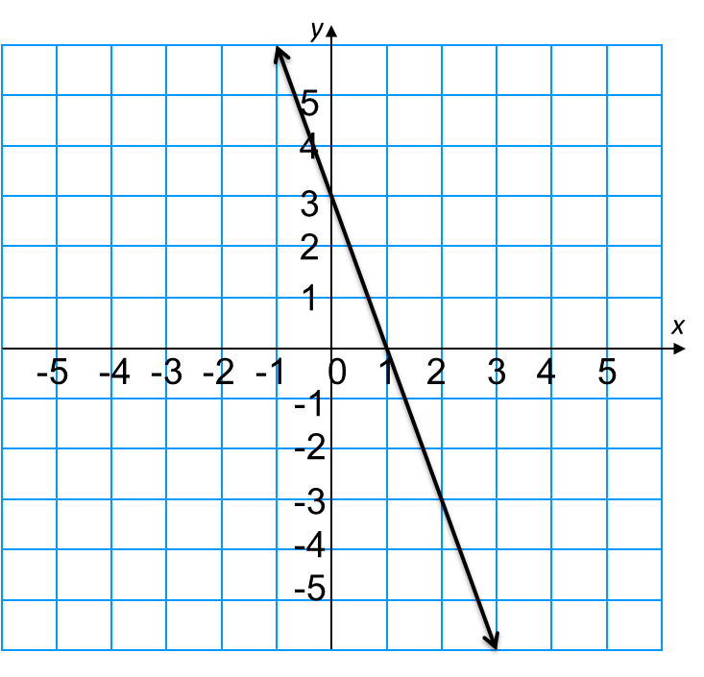 |  |  |  |  |  |  |  | Marks
 | a. | Determine the gradient of the line |  |  |  |  |  |  |  | 1
 | b. | Find the y-intercept of the line |  |  |  |  |  |  |  | 1
 | c. | Write the equation of the line in the form y = mx + b |  |  |  |  |  |  |  | 1
7. |  |  |  |  |  |  |  |  |  | Marks
 | a. | What is the equation of a line perpendicular to the line $y= 2x + 3$that goes through the point (2, 5) |  |  |  |  |  |  |  | 2
 | b. | Write the equation of the line that has the same y-intercept as the line $y= 2x + 3$ , and is parallel to the line $y=- \frac{x}{4}-4$ |  |  |  |  |  |  |  | 2
 | c. | A line has the equation $y = 4x – 6$. What is the gradient of a line parallel to this line? |  |  |  |  |  |  |  | 1
8. | Sketch the graphs given in parts a to c in the axes below  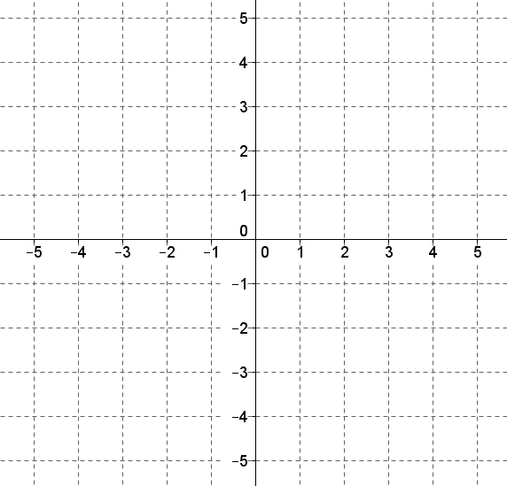 |  |  |  |  |  |  |  | Marks
 | a. | $$x=-4$$ |  |  |  |  |  |  | 1
 | b. | $$y= 4-x$$ |  |  |  |  |  |  | 2
 | c. | y = 3x - 4 |  |  |  |  |  |  | 2
9. |  | Use the length unit conversion graph to answer questions.  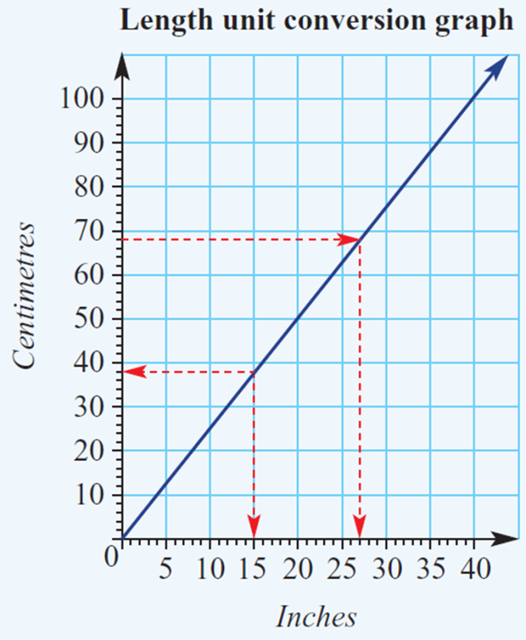
 | a. | Convert 94 cm to inches and use these values to find the gradient of the line, to 2 decimal places.? |  |  |  |  |  |  | 1
 | b. | Use your previous answer to find the constant of proportionality k and write the direct proportion equation between centimetres (y) and inches (x). |  |  |  |  |  |  | 1
 | c. | Use the equation to calculate the number of centimetres in 50 inches. |  |  |  |  |  |  | 1

Questions 10 to 14 Multiple choice
Right- Angled Triangles
20 marks
Attempt all Questions
Questions 10 to 14 Multiple choice
Allow about 15-20 minutes for this section

Circle the correct answer for Questions 10 to 13

10. |  | 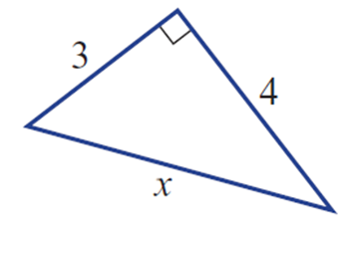  The correct working out to calculate the side a in the triangle shown below is:
 |  | - $x=\sqrt{\left(4^{2}- 3^{2}\right)}$ |  |  |  |  | - $x=\sqrt{\left(4^{2}+ 3^{2}\right)}$
 |  | - x = 4 - 3 |  |  |  |  | - $x=4+3$
11. |  | In the triangle below the ratio tanθ is given by:  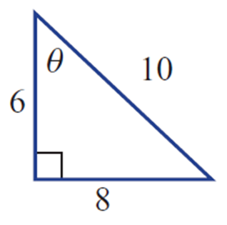
 |  | (A) $\frac{8}{10}$ |  |  | (B) $\frac{8}{6}$ |  | (C) $\frac{6}{10}$ |  | (D) $\frac{8}{10}$
12. |  | A measurement of an angle is found to be 82°40′15″. What is this measurement rounded to the nearest degree?
 |  | (A) 82º |  |  | (B) 83º |  | (C) 43º |  | (D) 44º
13. |  | The bearing of B from A is 150º as shown in the diagram The angle θ is therefore:  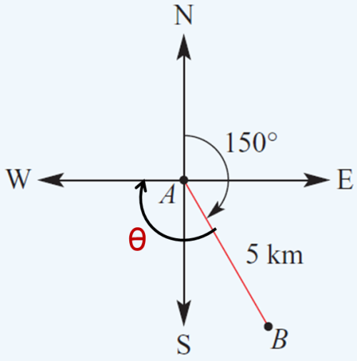
 |  | (A) 125º |  |  | (B) 120º |  | (C) 150º |  | (D) 55º
Questions 14-17 Short Answer. Show all working. Marks are as shown

14. |  |  |  | Find the side length x in these right-angled triangles. |  |  |  |  |  |  |  | Marks
 |  | a. |  | 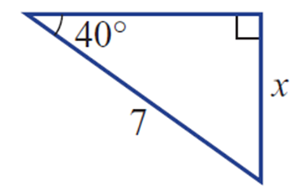 |  |  |  |  |  |  |  | 2
 |  | b. |  | 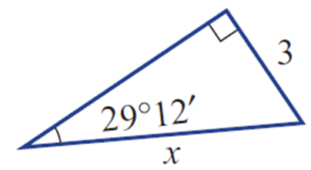 |  |  |  |  |  |  |  | 2
15 |  |  |  | Find the missing angle θ in these right-angled triangles, to the nearest minute |  |  |  |  |  |  |  | Marks
 |  | a. |  | 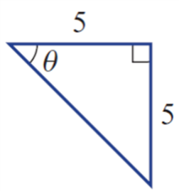 |  |  |  |  |  |  |  | 2
 |  | b. |  | 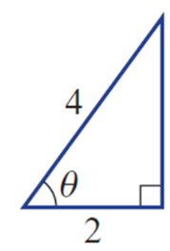 |  |  |  |  |  |  |  | 2
16. |  |  |  | A plane leaves an airport and flies 600 km on a bearing of 145°.  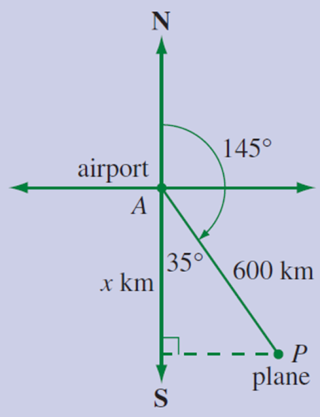 |  |  |  |  |  |  |  | Marks
 |  | a. |  | How far south of the airport is the plane (to the nearest km)? |  |  |  |  |  |  |  | 2
 |  | b. |  | What is the three-figure bearing of the airport from the plane? |  |  |  |  |  |  |  | 2
17. |  | This question refers to the diagram below  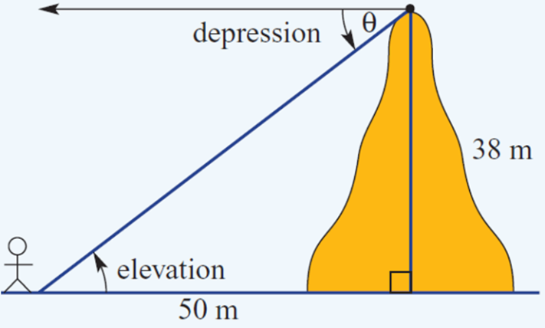 |  |  |  |  |  |  |  |  | Marks
 |  | a. |  | Find the angle of depression from the top of the hill to a point on the ground 50 m from the middle of the hill. Answer to the nearest degree. |  |  |  |  |  |  | 2
 |  | b. |  | What is the angle of elevation from the point on the ground to the top of the 38 m hill? Give your answer to the nearest degree. |  |  |  |  |  |  | 2
Equations
20 marks
Attempt all Questions
Questions 18 to 21 Multiple choice
Allow about 15- 20 minutes for this section

Circle the correct answer for Questions 15 to 18

18. | The solution to $x+5 =8$ is:
 | (A) $x=4$ |  |  |  |  | (B) $x=3$ |  | (C) $x=2$ |  | (D) $x=5$
19. | The solution to $8x=24$ is:
 | (A) $x=4$ |  |  |  |  | (B) $x=2$ |  | (C) $x=3$ |  | (D) $x=5$
20. | The solution to 3x - 4 = 8 is :
 | (A) $x=4$ |  |  |  |  | (B) $x=5$ |  | (C) $x=3$ |  | (D) $x=2$
21. | Which line of working is a correct next step in solving the equation below:  $$\frac{3x}{7}+5=4x +1$$
 | (A) $$3x+5=4x +1$$ |  |  |  |  | (B) $$\frac{3x}{7}=4x +6$$ |  | (C) $$\frac{3x}{7}=4x-4$$ |  | (D)  $3x+5=7(4x+1)$
Questions 22-25 Short Answer. Show all working. Marks are as shown

22. |  |  | Solve the following Show all working |  |  |  |  |  |  |  |  |  |  | Marks
 | a. |  | $$4x + 5 = 17$$ |  |  |  |  |  |  |  |  |  |  | 1
 | b. |  | $$3x + 4 = x + 12$$ |  |  |  |  |  |  |  |  |  |  | 2
 | c. |  | $$\frac{2x+2}{3}=4$$ |  |  |  |  |  |  |  |  |  |  | 2
23. |  |  | Substitute into the following formula and solve for the given pronumeral |  |  |  |  |  |  |  |  |  |  | Marks
 | a. |  | $v = u + at$ find t when v = 16, u = 4 and a = 3 |  |  |  |  |  |  |  |  |  |  | 1
 | b. |  | $V = πr^{2}h$ find h (to 1 decimal place) when V = 160 and r = 3 |  |  |  |  |  |  |  |  |  |  | 2
24. |  |  | Solve the following Show all working |  |  |  |  |  |  |  |  |  | Marks
 | a |  | 2x - 9 = x - 10 |  |  |  |  |  |  |  |  |  | 2
 | b |  | 3(2x + 3) + 2(x + 4) = 25 |  |  |  |  |  |  |  |  |  | 3
25 | For each of the following statements, write an equation and solve for the pronumeral.  a n is multiplied by 2, then 5 is added. The result is 11.  b Four times a certain number is added to 9 and the result is 29. What is the number?  c A number plus 6 has been divided by 4. The result is 12. What is the number? |  |  |  |  |  |  |  |  |  |  |  | 3

END OF EXAM

Blank Page

